VIGILANCE AWARENESS WEEK OBSERVED IN THE VIDYALAYA
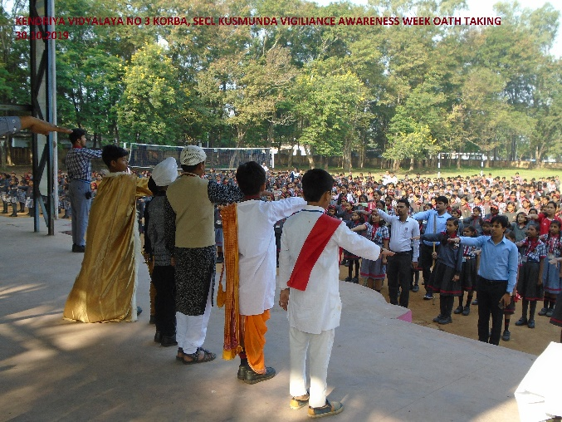 OATH TAKING 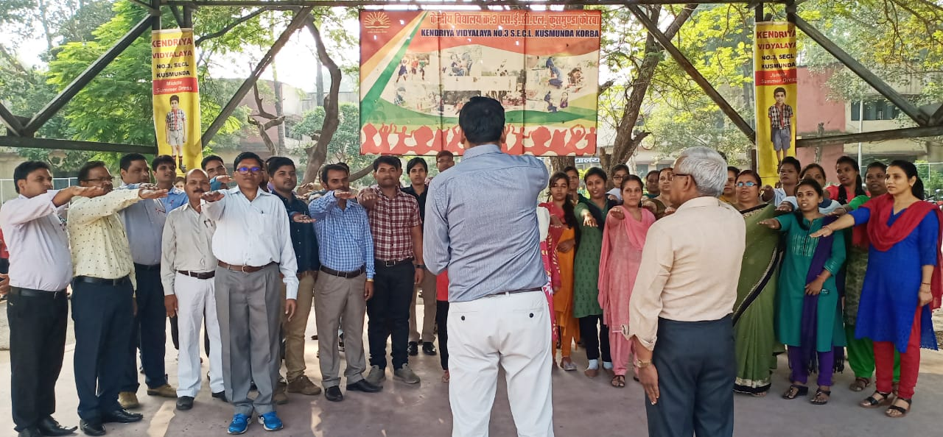 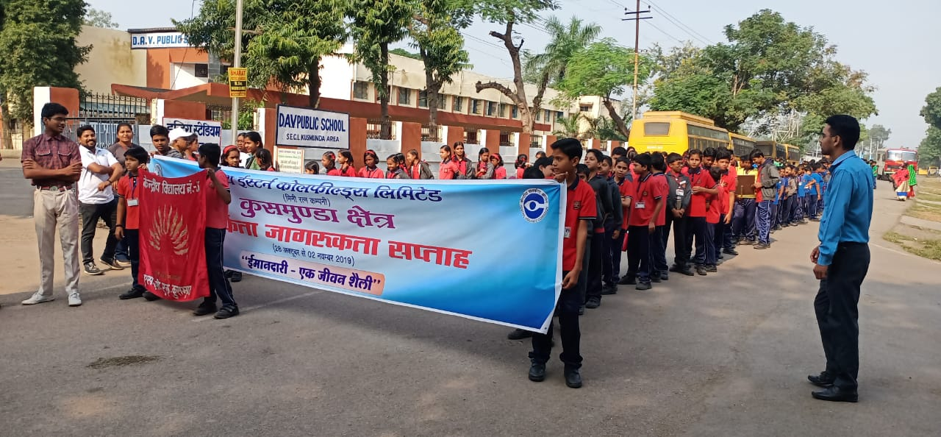 RALLY ORGANISED

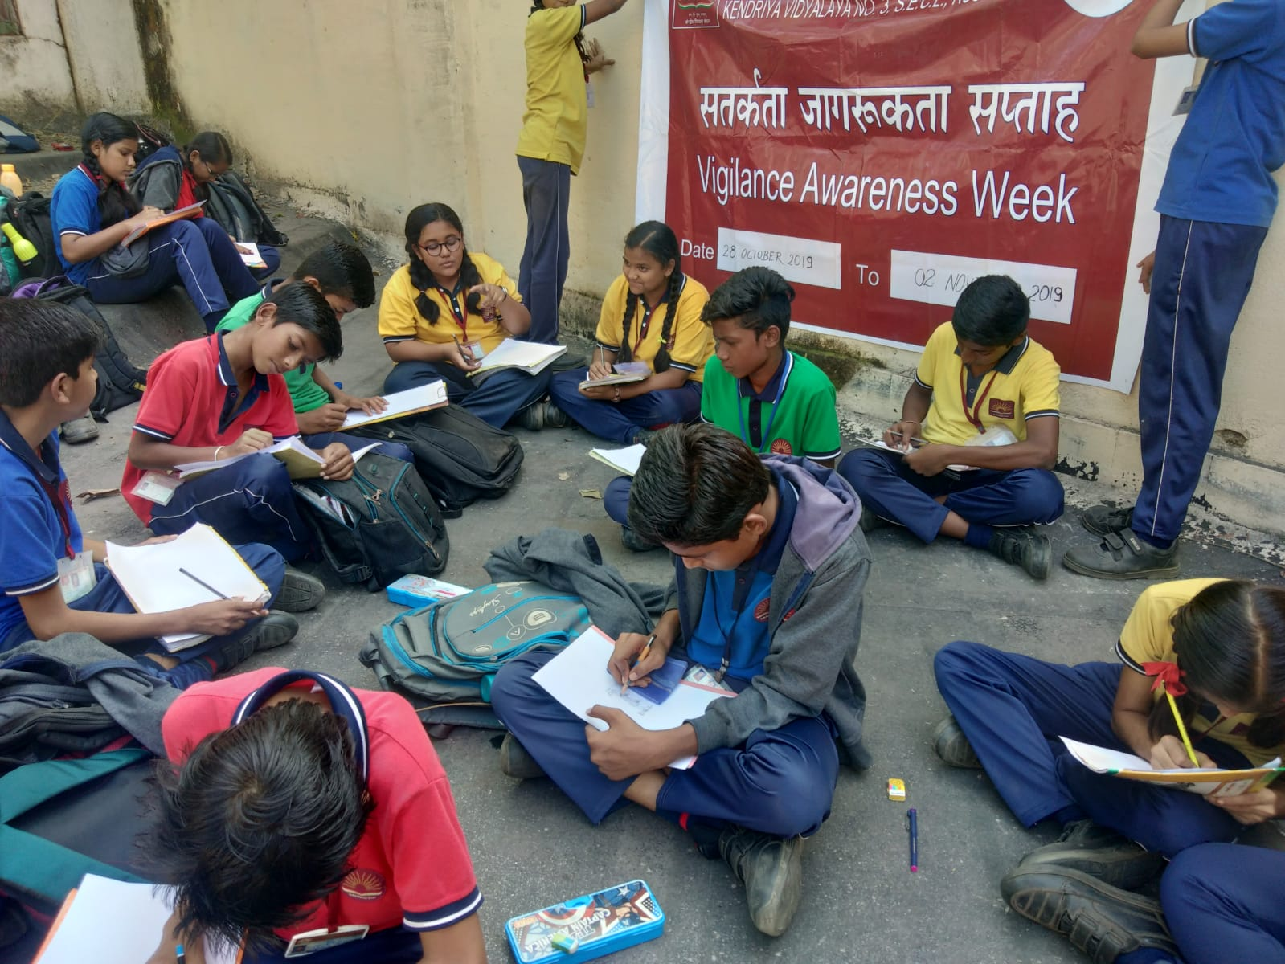
PAINTING COMPETITON ORGANISED.

